APPALACHIAN LANDSCAPE
CONSERVATION COOPERATIVE GRANT
2013 PROGRESS REPORT

Quarter: (circle one) 2013 1st 2013 2nd 2013 3rd 2013 4th

Grant Number and Title: 2012-02; Assessing Future Impacts of Energy Extraction in the Appalachian LCC

Grant Receipt/Organization: The Nature Conservancy

Grant Project Leader: Joseph Kiesecker/Judy K. Dunscomb

Were planned goals/objectives achieved last quarter? YES

ALCC Need Addressed: Forecasting Resource Extraction

Progress Achieved: (For each Goal/Objective, list Planned and Actual Accomplishments)

Coal Model: Our WVU Contractor has completed a final coal model covering the entire LCC, which indicates that though the extent of future surface mining will vary regionally, the highest probability areas are concentrated in the mountaintop removal/valley fill mining region of central Appalachia. The contractor received significant feedback on their model from the technical Oversight Team and from industry experts and outside stakeholders, and has made significant efforts to incorporate this feedback into the final model.
Significant comments from reviewers and how they were addressed include:
- Recommendations to include more direct geologic variables; [The WVU team searched extensively for geologic data sets that covered the Apps LCC region and were unable to locate these.]
- A finding that depth of overburden is a critical determinant of surface mining feasibility; [The WVU team was again unable to obtain this dataset for the whole region, although very good data exist for West Virginia. In lieu of direct assessment of overburden, the team used a data layer from EPA delimiting the area of mountaintop removal coal mining as a categorical variable in the model, meaning that one of the first splits in the model tree is whether and area is within or outside of the region for which large area surface mines are known.]
- Skepticism regarding the significance of existing power plants as a meaningful driver of future surface mining; [See model validation comments below] and,
- Concern about the lack of empirical model validation. [The team worked with Jeff Evans to develop an R-script which would compare the performance of the model against a series of random predictions to produce an estimate of model error. This script proved difficult to adapt to the model, and final validation results will be provided in an interim report, however the results that were obtained do show that each variable included in the model adds more in explanatory power than it generates error. Therefore the final variable list will be retained. model output indicates a good empirical fit (out of bag estimates of 13-15%) based on evaluations of the significant tests of variables and overall model performance. We are continuing to examine the model output with additional techniques from recent literature to further aid in validation. An interim report will add additional validation results from these additional tests.]

For details on model variable selection and development please see accompanying draft final report (click title for link) “Development of a Spatially Explicit Surface Coal Mining Predictive Model”, and for a list of variables used in the final coal model please see Table 1, below.

Shale Gas Model: We have completed 3 Shale-gas models: A detailed model at only a subset of the Appalachian LLC (= Marcellus Shale Play, see previous progress reports) and a lower resolution model across the entirety of the Appalachian LLC (see model predictions below) and a model across a portion of the Utica Shale Play (see model predictions below). For details on the model development see previous progress reports and for a list of variables used in the LCC and Utica model see Table 1 below.

Shale Gas Scenarios: For the Marcellus model where data on potential development patterns (i.e. amount of wells, resource recovery estimates) was available we developed a detailed development scenario (see previous progress reports). But for the LCC model where potential production data is limited and uncertainties with the spatial prediction in the southern portion of the LCC model we did not develop a detailed development scenario. Similarly for the Utica specific model we did not develop any detailed development scenario given limited data. For both of these models we used a threshold of 0.90 probability within the model predictions to highlight areas of likely development. (see Figure 2 & 3 below)

Wind Development Model: We have completed 2 wind models: A high resolution model at only a subset of the Appalachian LLC (= Marcellus Shale Play, see previous progress reports) and high resolution model across the entirety of the Appalachian LLC (see Figure 3 below).

Wind Development Scenarios: Similar to shale gas models we created a detailed development scenario only for the area Marcellus region. To examine areas where development risk will likely be high for wind we selected a threshold (= 0.90) for the predictive models. We then intersected these areas with forest cover to identify forested areas at risk of development (see figures below). We also calculated the percent of the LCC that intersects each EWITS analysis region and, using scenario 3, calculated projected megawatts, number of required turbines and impacted acres (using 15.30 ac as per-turbine impact).

Web Map Server: Models and data from all development projections - shale gas, wind & coal are available for download through the webmap server which was made accessible on September 30. The web map server can be found at: http://s3.amazonaws.com/DevByDesign-Web/MappingApps/CentralApps/demo/central_apps.html

Table 1. Model variables for LCC Coal, LCC & Utica Shale & LCC Wind Models
Coal Model | Utica Model | Shale Gas Model | Wind Model
Ash content | Bouguer anomalies | Bouguer anomalies | Surface dissection 3x3
BTU content | Isograv anomalies | Isograv anomalies | Wind Production classes
Coal geology type | Magnetic anomalies | Magnetic anomalies | Distance to transmission
Distance to intermodal | Shale depth | geology | Surface roughness 9x9
Distance to power plants | Shale thickness
Distance to rail | Geology
EIA Coal Region | Surface dissection 3x3
Mountaintop Removal Region
Population Density
Sulfur Content

Table 2. Percent of the LCC study area that intersects each EWITS analysis region and calculated projected megawatts, number of required turbines and impacted acres (using 15.30 ac as per-turbine impact) projected based on EWITS scenario #3.

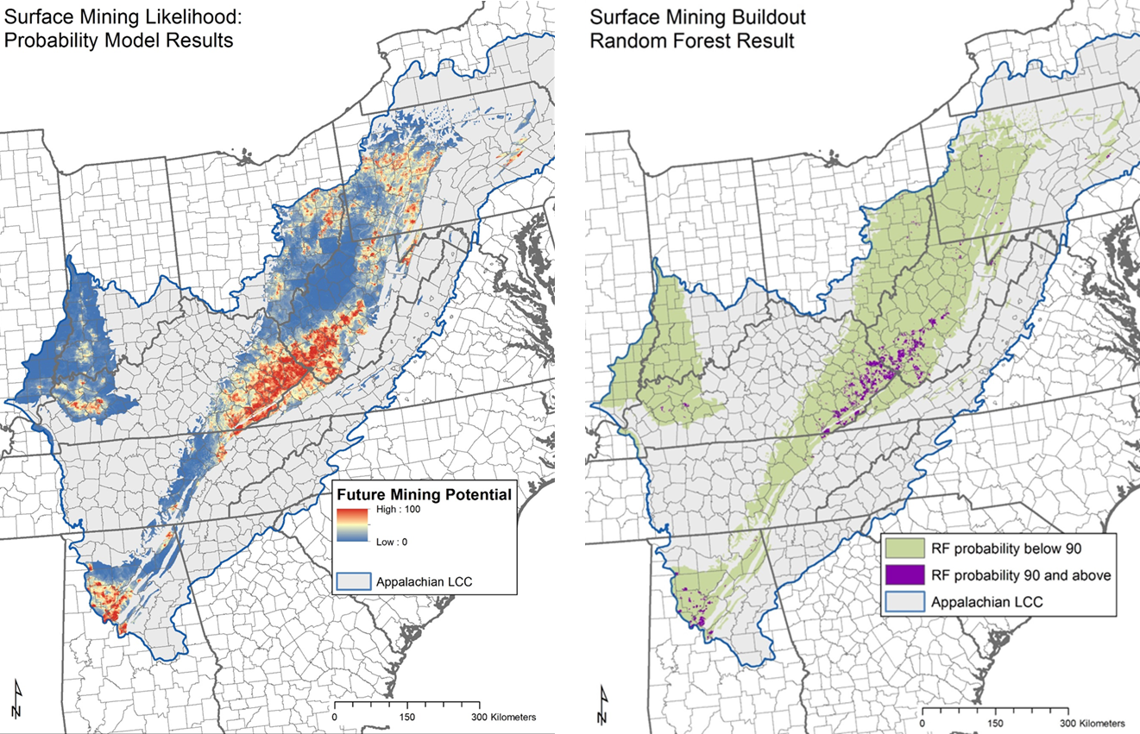
Figure 1a) probability of surface coal mining ramped where blue is low and red is high probability; b) Areas with surface coal mining potential p>=0.90.
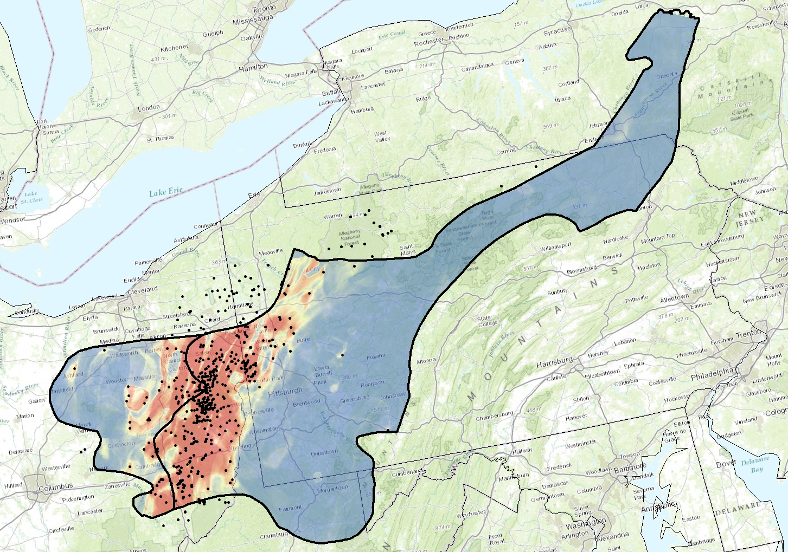
Figure 2: Probability of gas development from Utica Shale Model; color ramped where blue is low and red is high probability.

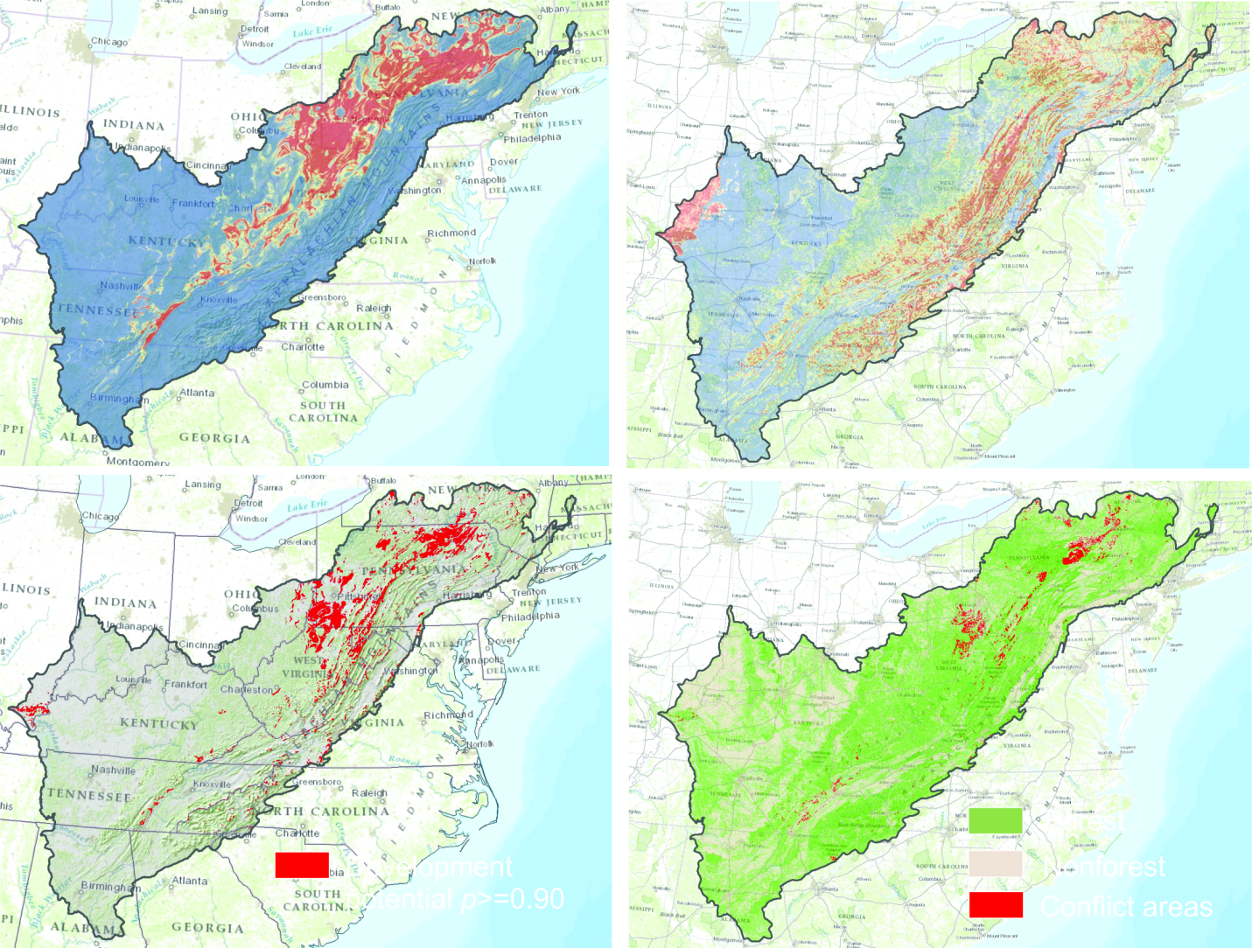
Figure 3a) probability of gas development color ramped where blue is low and red is high probability; b) probability of wind development color ramped where blue is low and red is high probability; c) Areas with gas and wind development potential p>=0.90

Summary of Progress: (Provide a paragraph describing progress, work to come, and timelines)

Models that depicts the probability of coal, shale gas, and wind energy development across the Appalachian Landscape Conservation Cooperative are completed; Coal scenarios have been developed across the whole LCC, and Shale Gas and Wind development scenarios have been completed across the a subset of the LCC study area for the Marcellus and Utica Shale Plays. We have also completed a development scenario for wind across the entirety of the Appalachian Landscape Conservation Cooperative.

Difficulties Encountered: As noted above, the detailed coal geology data desired by reviewers is not available for the entire analysis region. We have also been unable to acquire detailed data for shale gas model scenarios across entire study area. Information that can be used to generate detailed shale gas development scenarios is currently only available for the Marcellus Formation. Estimates as to the extent of shale gas development in formations outside the Marcellus are limited. We have also gathered anecdotal information that to date ~40 wells have been drilled in the Chattooga, New Albany, Conasauga, Floyd & Neal plays within the LCC study area, but have been unable to acquire specific locations for these wells.

Activities Anticipated Next Quarter: Compile and generate resource layers to overlay with energy development maps to give context to anticipated impacts; Create final report; Complete metadata associated with GIS datasets; Populate and get feedback on web map server.

Expected End Date: January 30, 2014. Final report to be delivered by 2/14/2014.

Costs:

Funds Expended to Previous to this Report: $52,132.87

Amount of ALCC Funds Requested within this Report: $9,247.13 (Note: Previous Two payments request have not been received)

Total Approved Budgeted ALCC Funds: $216,329.13

Are you within the approved budget plan? YES

Are you within approved budget categories? YES

Signature:
Date: 10/30/2013

